**UCS 2312 Data Structures Lab**

**Assignment 8: Binary Heap and its applications**

Implement Priority Queue using Binary Heap. priorityQueueADT consists of integer element.

Implement the following methods.

[CO2, K3]

* void insert(struct priorityQueueADT *P, int x) – Insertion new item into priority queue using Max Heap property
* int delete(struct priorityQueueADT *P) – Will remove the root of binary heap
* void display(struct priorityQueueADT *P) – Will display the contents pf Priority Queue

1. Demonstrate ADT with the following testcase insert(p,14); insert(p,16); insert(p,22); insert(p,11); insert(p,9); insert(p,18); insert(p,10); insert(p,7); insert(p,4);

insert(p,1);

1. Write an application to design a priority queue using max binary heap. An item in the priority queue consists of employee id and salary amount. The queue supports two operations, namely, insertion and deletion.

Test the application with the following insert(p,(‘A’,15000)); insert(p,(’K’,12000)); insert(p,(‘R’,4000)); insert(p,(‘T’,3500)); insert(p,(‘L’,4600)); insert(p,(‘P’,6000));

insert(p,(‘Y’,8600));

Output:

Employees are removed in the following order

(‘A’,15000), (’K’,12000), (‘Y’,8600), (‘P’,6000), (‘L’,4600), (‘R’,4000), (‘T’,3500),

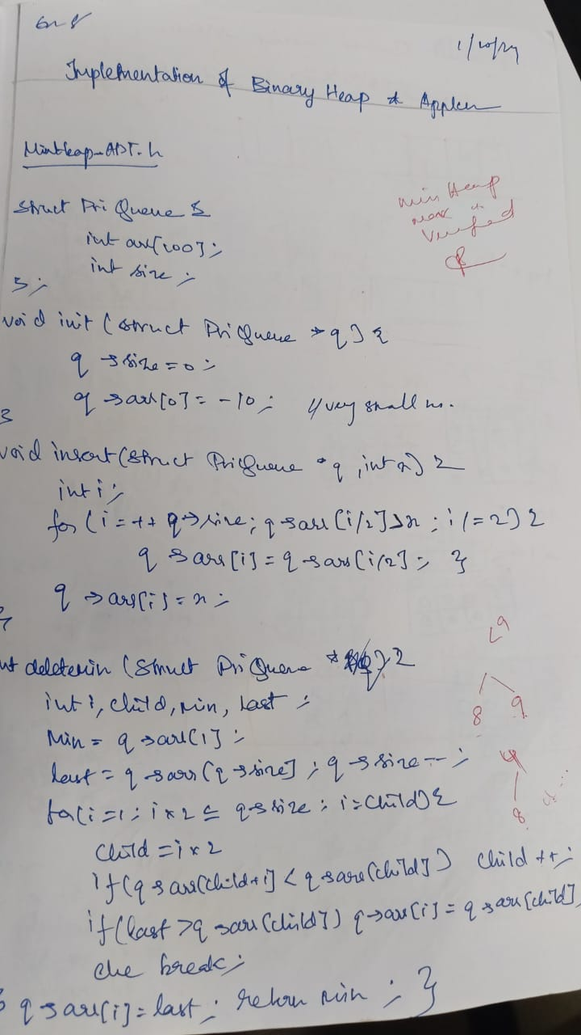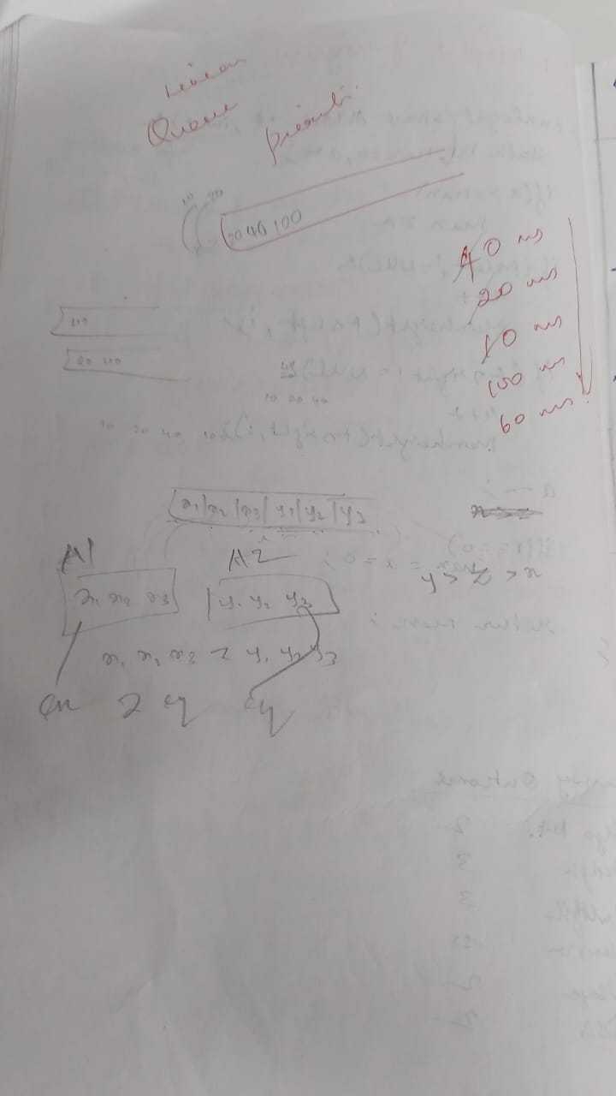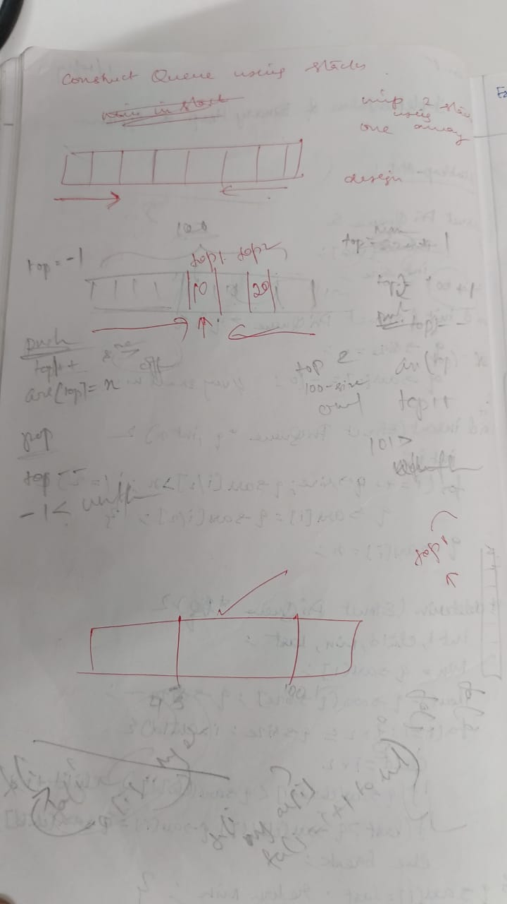

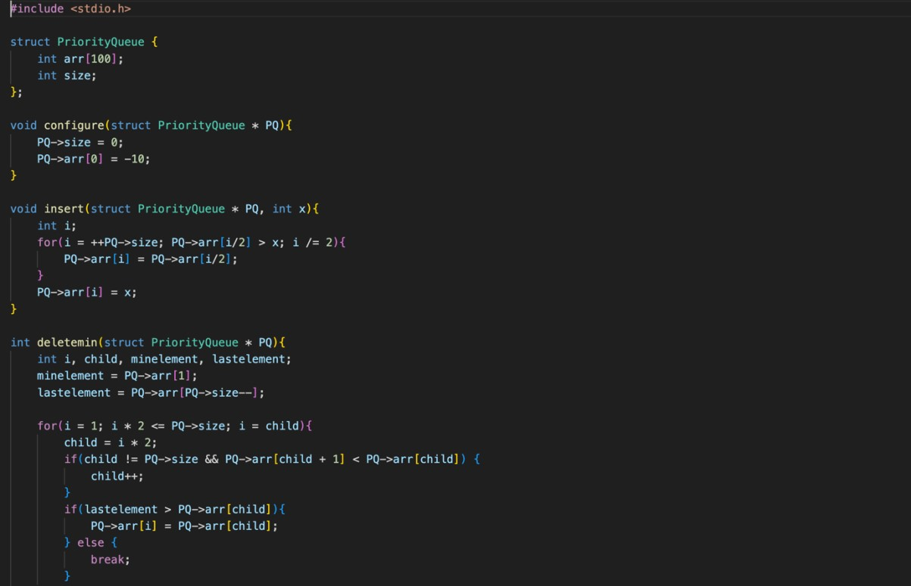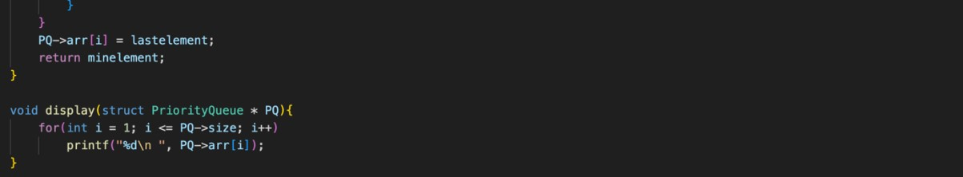

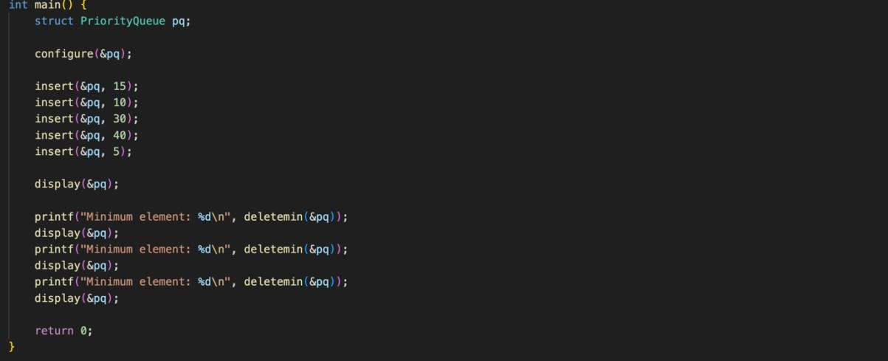

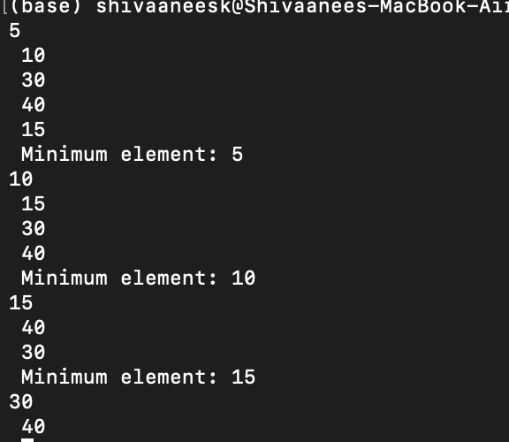

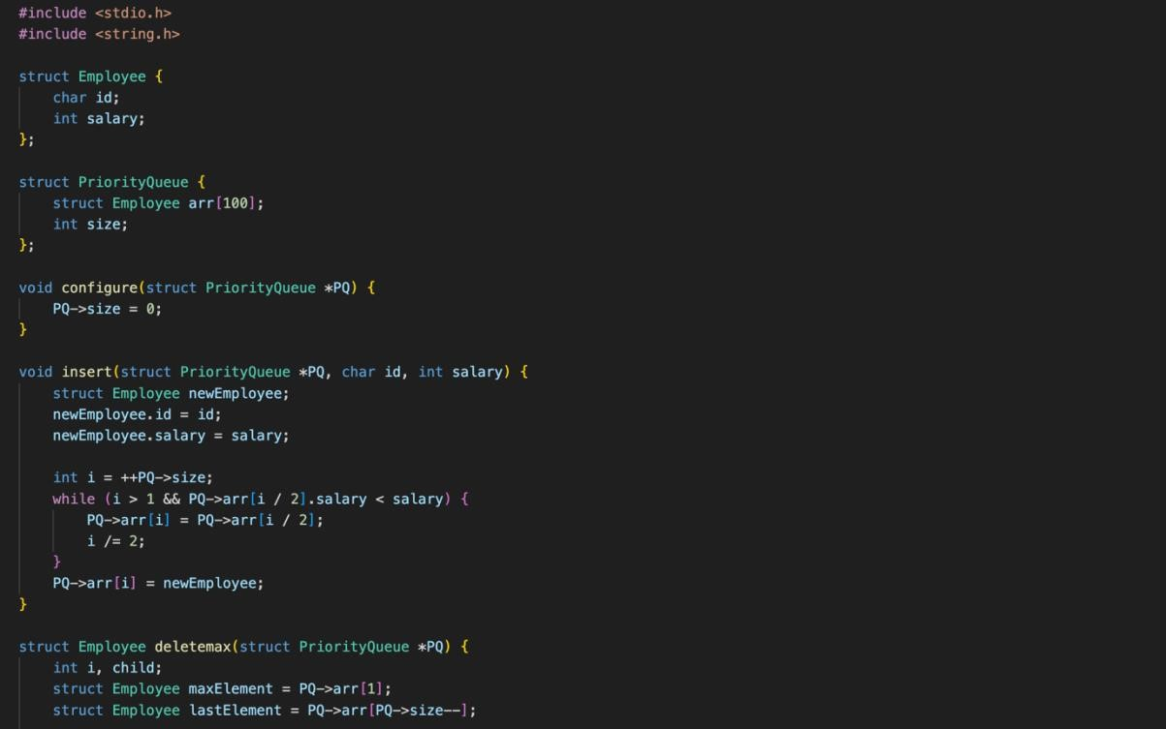

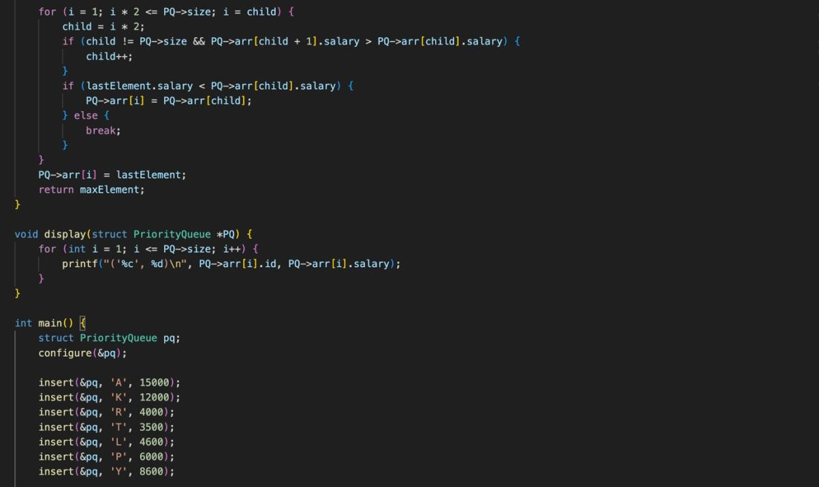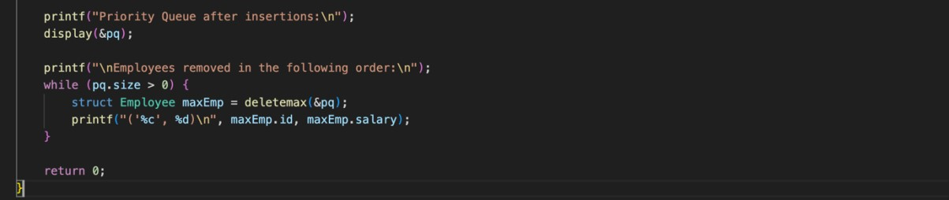

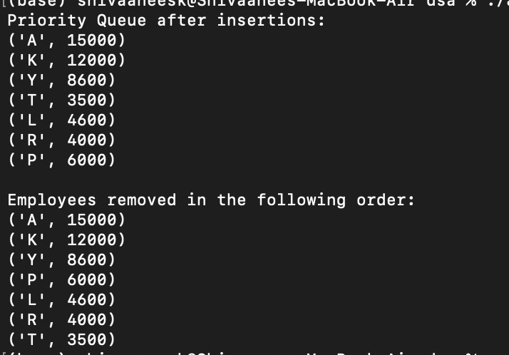

Technical Outcomes:

|  |  |  |
| --- | --- | --- |
| Design | 3 |  |
| Understanding DS | 3 |  |
| Usage of DS | 2 | Needs improvement |
| Debugging | 3 |  |

Best Practices:

|  |  |  |
| --- | --- | --- |
| Design before coding | 3 |  |
| Usage of algo | 3 |  |
| Multifile | 2 | Needs improvement |
| versioning | 3 |  |